Fisheries as social-ecological systems

Commercial and recreational fisheries form social-ecological systems (SESs; Hunt et al. 2013; Weber et al. 2019), consisting of social, ecological, and governmental subsystems (Ostrom 2007). In the social subsystem (Figure 1b) diverse human actors and organizational structures influence each other’s decisions and activities through social norms, cooperation, competition, and knowledge sharing. Whereby these actors influence the resource system with their individual decisions about where, when, what, how often, or how to fish (Allan and Flecker 1993; Lewin et al. 2006). In a fisheries context, the ecological resource system comprises the whole ecosystem with the target fish stock, other species, and the environment (Figure 1a; Hunt et al. 2013). The resource system influences the actors’ decisions due to spatial and temporal variations in the abiotic (weather, wind, etc.) and biotic (stock dynamics, migration, etc.) components (Figure 1b). In addition, the governmental subsystem including the fisheries management applies regulations and constraints on the social subsystem (Figure 1c). The various instruments of fisheries management include input controls such as gear restrictions or output controls such as catch allocations, with the goal of creating sustainable fisheries which simultaneously maintain fish stocks, fishing opportunities, jobs, and user welfare.

(a) Ecological subsystem (b) Ecological and Social subsystem

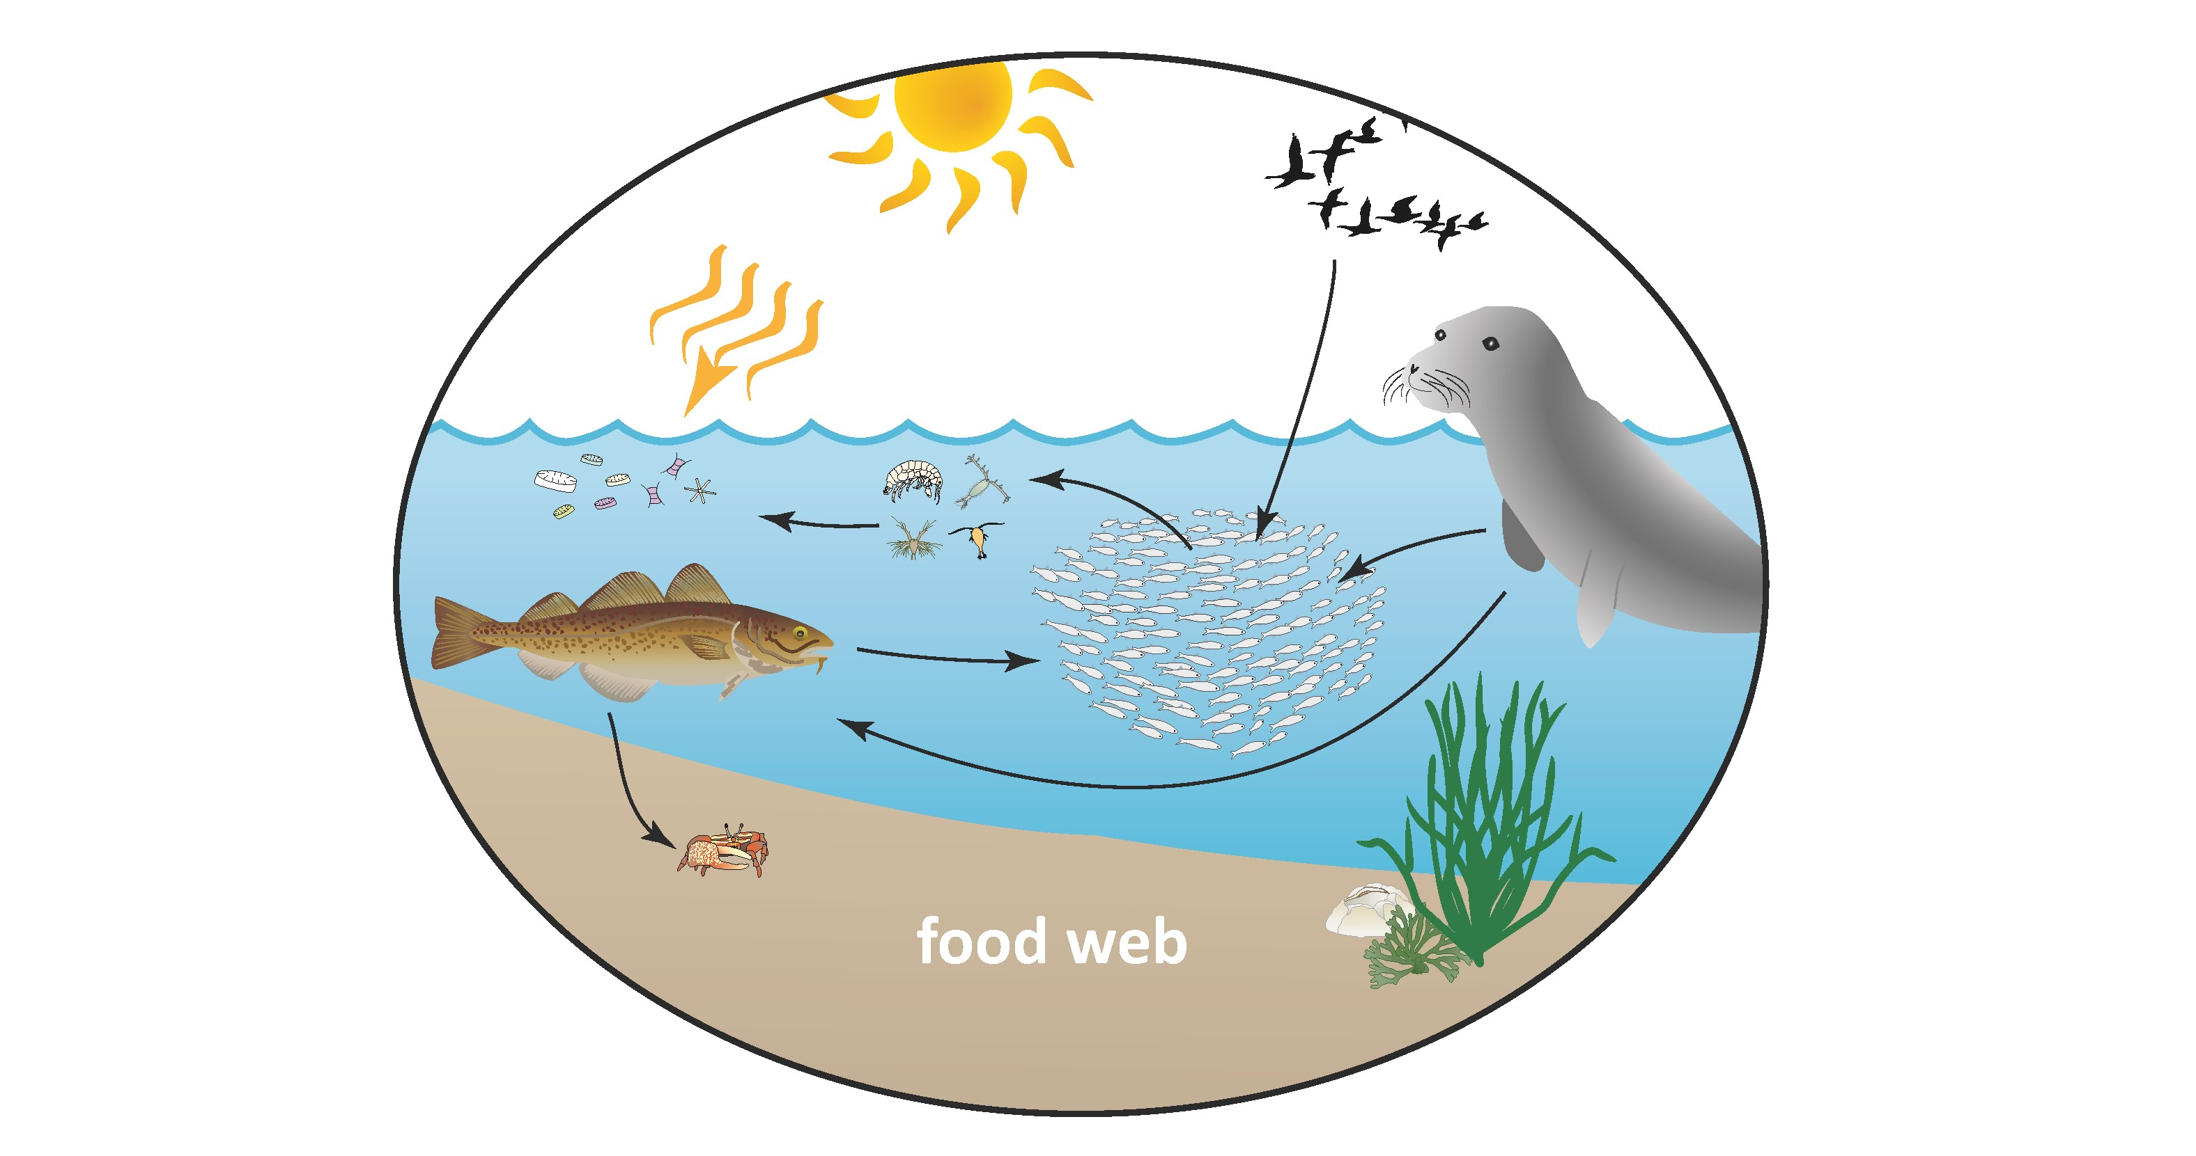



(c) Total SES

Figure 1: Scheme of a social-ecological fisheries system. (a) shows the ecological subsystem, (b) the social subsystem including the interactions with the ecological subsystem, and (c) the governance subsystem and the interactions with the other subsystems

# References

Allan JD, Flecker AS. 1993. Biodiversity Conservation in Running Waters. BioScience. 43(1):32–43. https://doi.org/10.2307/1312104

Huber R, Bakker M, Balmann A, Berger T, Bithell M, Brown C, Grêt-Regamey A, Xiong H, Le QB, Mack G, et al. 2018. Representation of decision-making in European agricultural agent-based models. Agricultural Systems. 167:143–160. https://doi.org/10.1016/j.agsy.2018.09.007

Hunt LM, Sutton SG, Arlinghaus R. 2013. Illustrating the critical role of human dimensions research for understanding and managing recreational fisheries within a social-ecological system framework. Fisheries Management and Ecology. 20(2–3):111–124. https://doi.org/10.1111/j.1365-2400.2012.00870.x

Lewin W-C, Arlinghaus R, Mehner T. 2006. Documented and Potential Biological Impacts of Recreational Fishing: Insights for Management and Conservation. Reviews in Fisheries Science. 14(4):305–367. https://doi.org/10.1080/10641260600886455

Ostrom E. 2007. A diagnostic approach for going beyond panaceas. Proceedings of the National Academy of Sciences. 104(39):15181–15187. https://doi.org/10.1073/pnas.0702288104

Weber CT, Borit M, Aschan M. 2019. An Interdisciplinary Insight Into the Human Dimension in Fisheries Models. A Systematic Literature Review in a European Union Context. Frontiers in Marine Science. 6:369. https://doi.org/10.3389/fmars.2019.00369